Title: Customer Satisfaction for Transport service application – Uber
Team Name: DataCraft
Authors: Roupyajay Bhattacharya, Umesh BP, Madipally Bhagath Chandra, Ninad Phadnis
Email Address:
roupyajayb@iisc.ac.in
bhagathchan1@iisc.ac.in
ninadphadnis@iisc.ac.in
umeshbp@iisc.ac.in
Problem
- Definition
- Transportation analytics for Cab Service application - Uber
- Problem motivation
- High churn rate due to poor customer experience.
- Need for actionable insights to improve driver availability, reduce cancellations, and enhance ratings.
- Competitive pressure to maintain and grow market share.
- Design Goals
- Scalability: Handle increasing data volumes from ridership across multiple regions.
- Low Latency: Ensure fast data access and processing.
- Features supported
- Real-time and batch data ingestion.
- ETL (Extract, Transform, Load) pipelines.
- Scalable storage and analytics.
- Predictive modelling for customer satisfaction.
- Dimensional modelling for efficient querying.
Approach
- High-level scalable Architecture design
  - Data collection --> Data Ingestion --> Extract, Transform and Load --> Storage --> Analytics

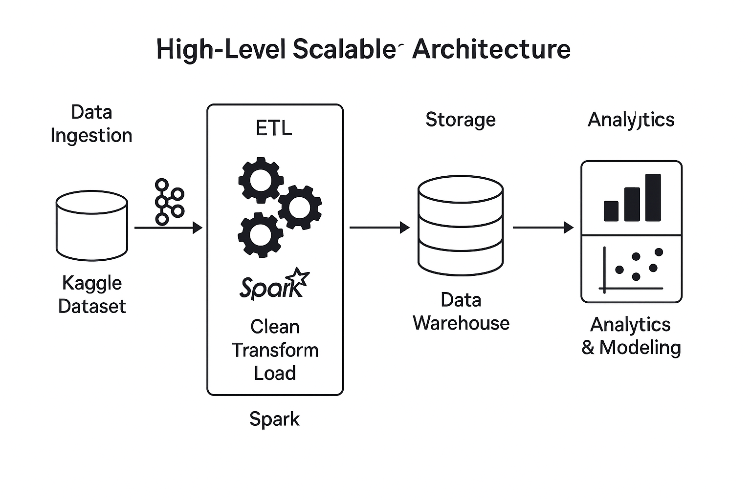
ETL : Load raw data from Kaggle or cloud storage. Handle missing values, outliers. Normalize ratings, trip durations. Feature engineering (e.g., time of day, location clusters). Store cleaned data into a scalable data warehouse. Spark clusters can handle large volumes via distributed processing.
- Big Data platforms used
  - Apache SPARK, PySpark, MLLib, Pandas, Seaborn, MatPlotLib, NumPy
- Data sources and data models
  - Data source: Kaggle
  - Data Model: Dimensional Modelling, Schema
Evaluation Approach
- Experiment plan
- Build and test ETL pipelines.
- Model customer satisfaction using historical data.
- Evaluate performance under increasing data loads.
- Performance metrics for success
  - Latency
  - Resource consumption / optimization
  - Model accuracy
- Feature metrics for success
  - Driver availability optimization.
  - Improved customer ratings.
  - Reduced trip cancellations.

Data Set Name and Link
Uber Ride Analytics Dataset 2024
https://www.kaggle.com/datasets/yashdevladdha/uber-ride-analytics-dashboard

Timelines and Milestones
Phase | Duration
Project Planning | 1 week
ETL Development | 2 weeks
Storage Setup | 0.5 weeks
Analytics & Modelling | 3 weeks
Performance Evaluation | 0.5 weeks

